# The Match is OVER: Using Window Functions

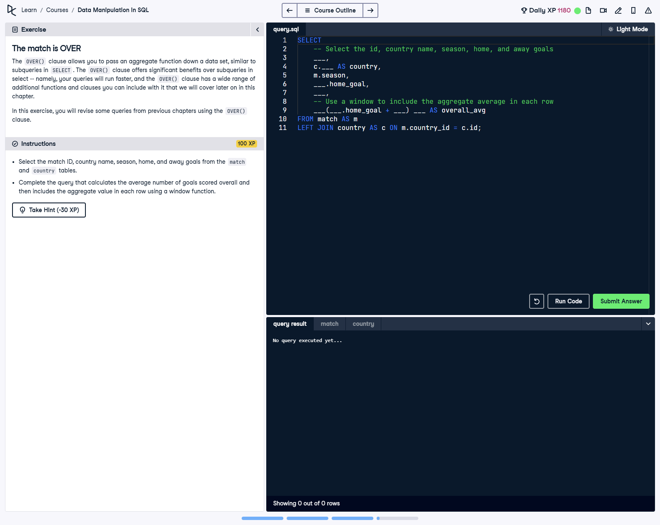

## Question

Select the match ID, country name, season, home, and away goals from the match and country tables. Complete the query that calculates the average number of goals scored overall and then includes the aggregate value in each row using a window function.

## Corrected Solution

SELECT  
 -- Select the match id, country name, season, home, and away goals  
 m.id,  
 c.name AS country,  
 m.season,  
 m.home_goal,  
 m.away_goal,  
 -- Use a window function to include the aggregate average in each row  
 AVG(m.home_goal + m.away_goal) OVER () AS overall_avg  
FROM match AS m  
LEFT JOIN country AS c  
ON m.country_id = c.id;

## Explanation

This query uses a window function to calculate the average number of goals scored across all matches. The 'OVER ()' clause ensures that the average is applied across all rows without grouping, allowing the average to be included as a new column in each row. A LEFT JOIN is used to combine the match table with the country table, retrieving the match ID, country name, season, and goals scored. The resulting dataset includes detailed match-level information along with the overall average goals.